**Data Factory Practical(blob to sql):**

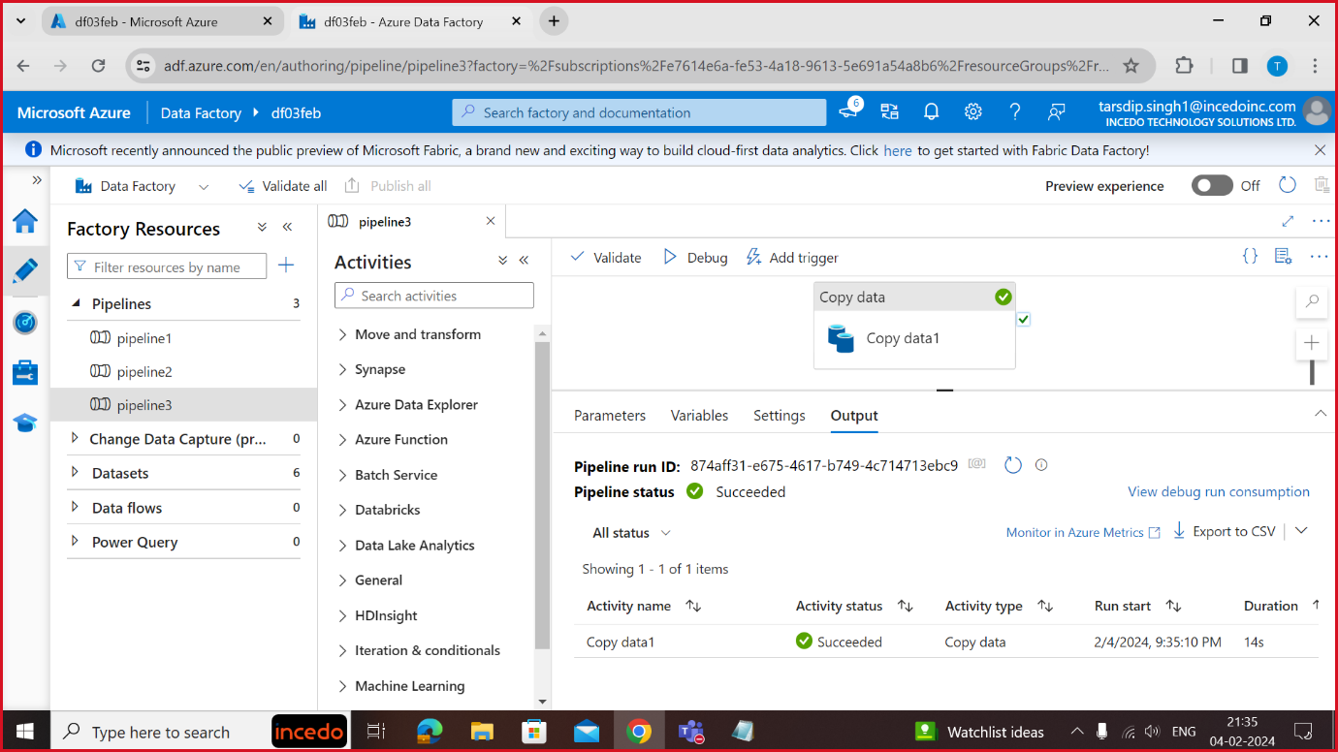

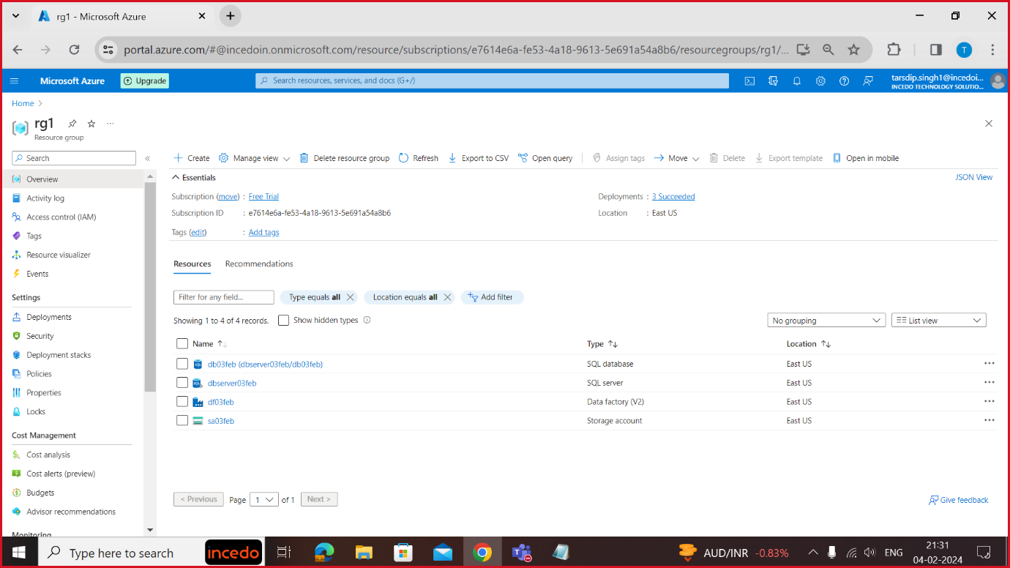

**Load Balancer Practical:**

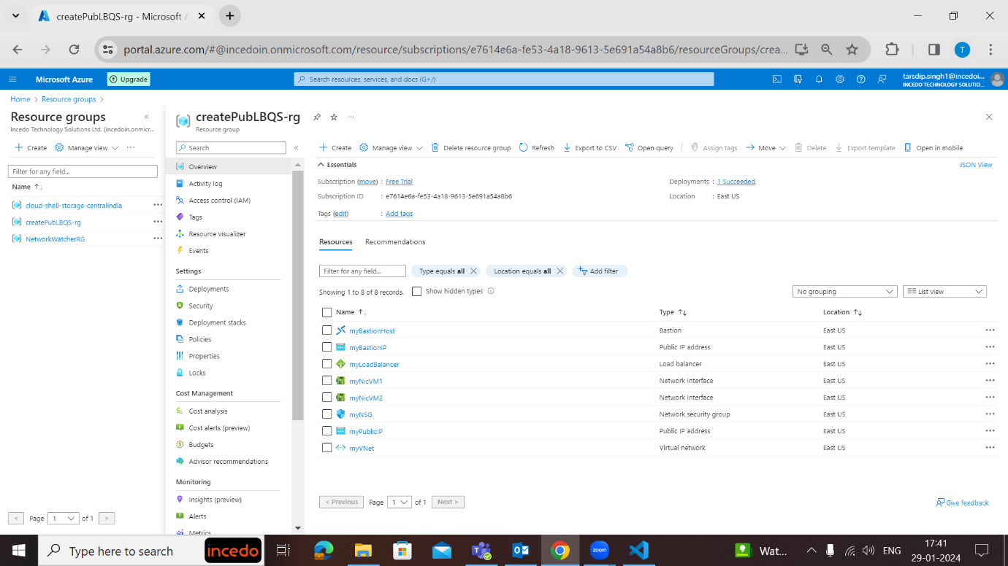

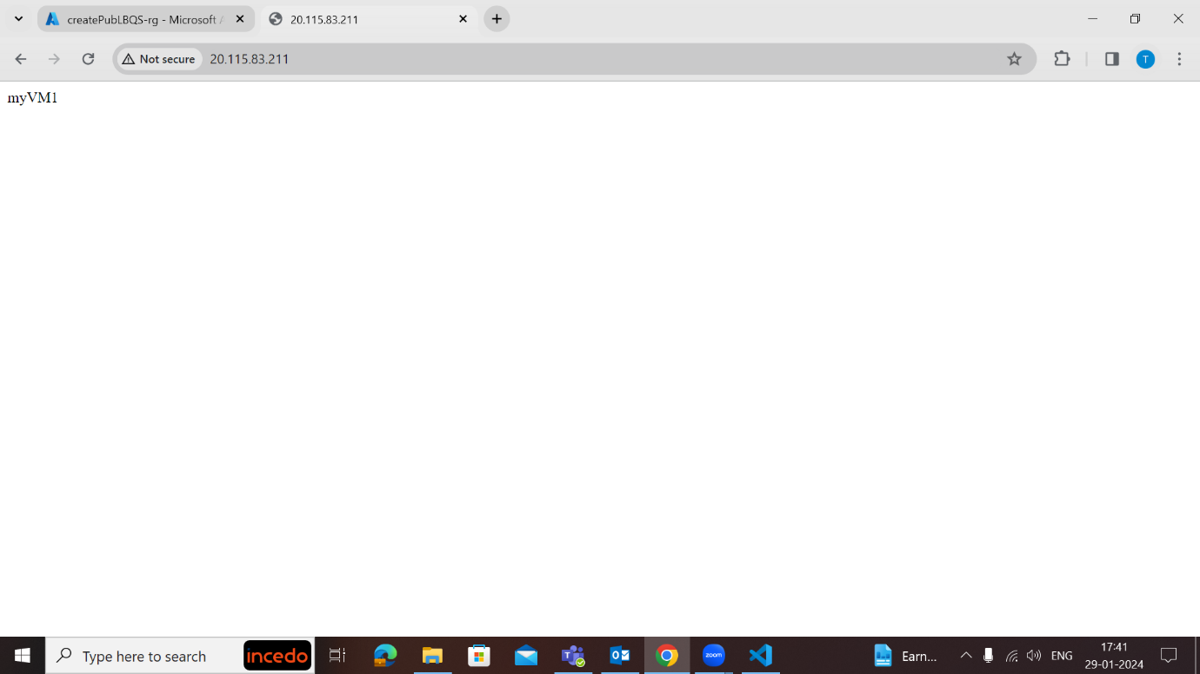

**Vnet Practical:**

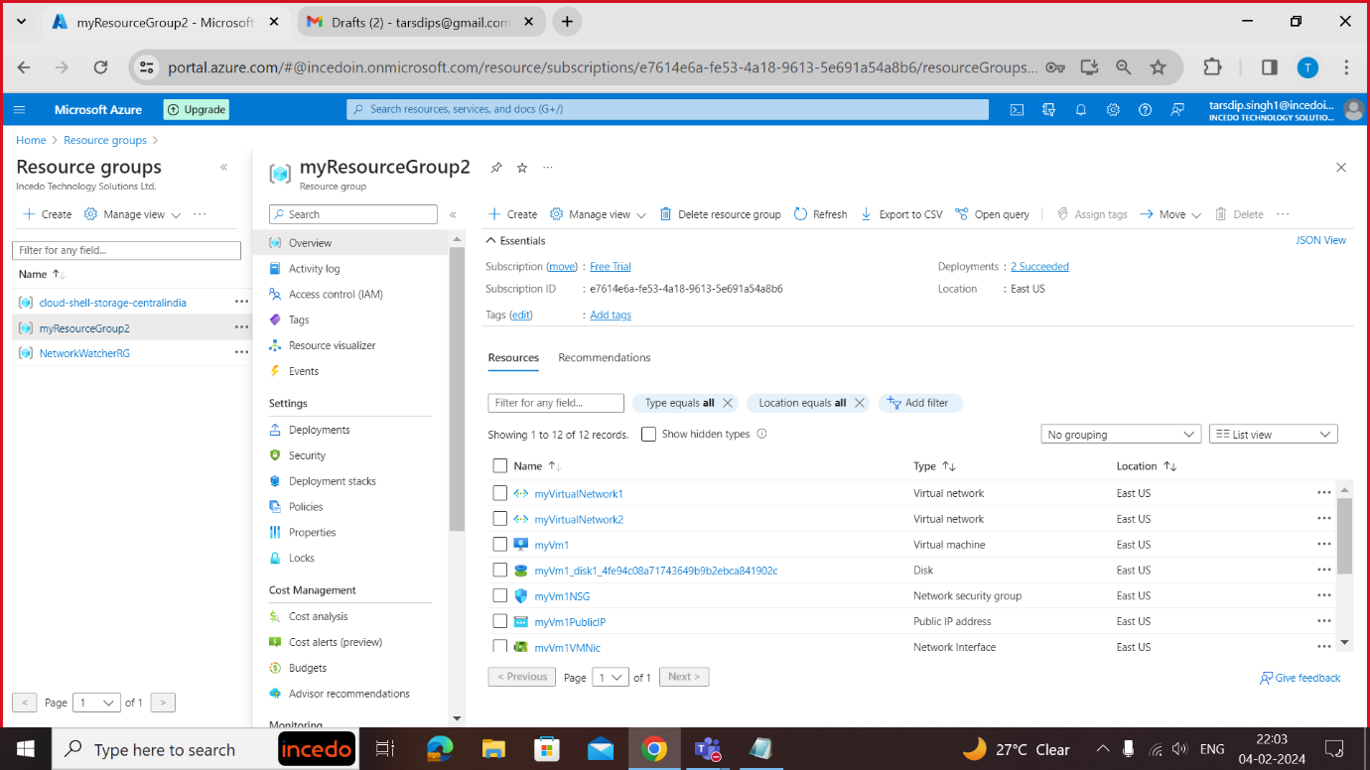

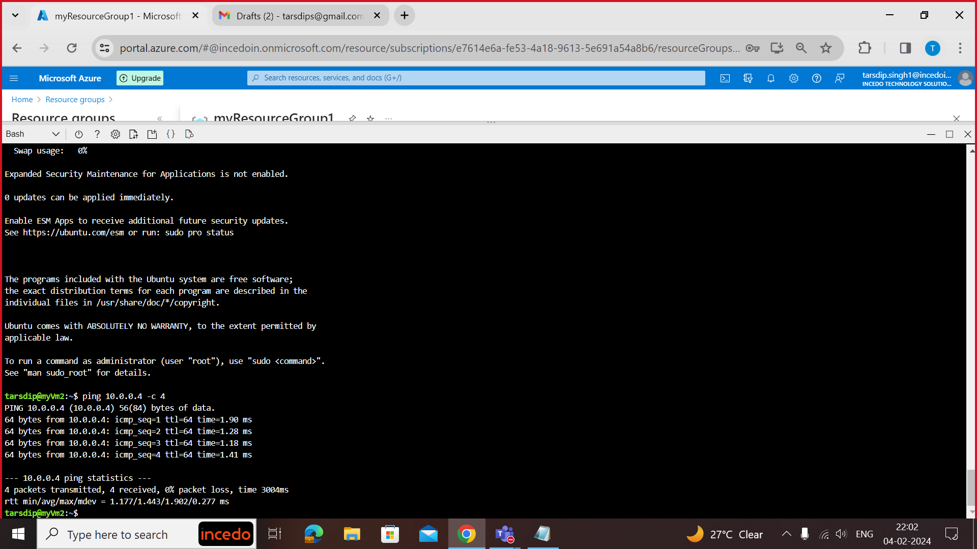

Rest of the small practices (vm creation, rg creation, etc) are not included as I was not aware that we have to take ss as proof before, so instead of wasting time doing them I have excluded them.